Labtest 1

Create an Android application that has the following functionality:

* Has a MainActivity that shows your name and student ID
* MainActivity should have the **menu or a button** that takes the user to SecondActivity
* SecondActivity displays the following form and a ListView:

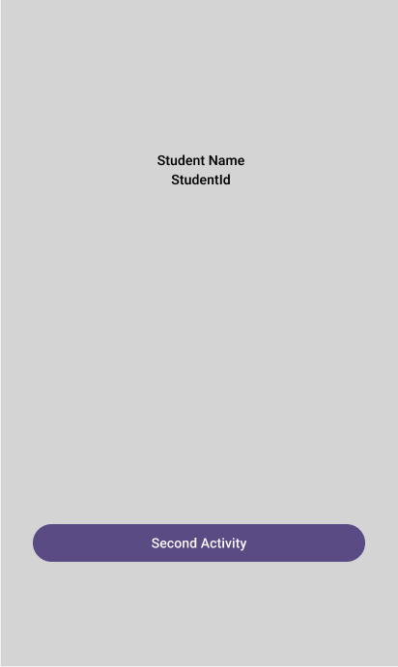

MainActivity SecondActivity

* Using form user can add items to a temporary storage (in memory)
* List should be updated after each element is added
* When List item is selected, a dialog should be displayed with the item information.

Submit z ZIP with your solution (entire project) on D2L before the end of the test.

**There will be no extension and no email submission will be accepted.**

**Marking Scheme**

|  |  |
| --- | --- |
| UI design | 20 |
| Button for navigation | 20 |
| Form in SecondActivity | 20 |
| List implementation | 20 |
| Dialog implementation | 20 |
| **Total** | 100 |